HackerRank - Solve Me First
Code:
int solveMeFirst(int a, int b) {
return a + b;
}

Screenshot:

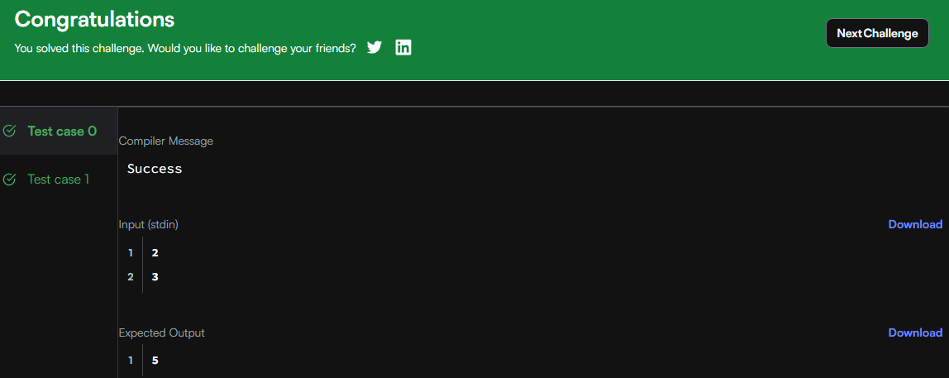

Link:
https://www.hackerrank.com/challenges/solve-me-first/problem

